Signal strengths and distances of a moving ESP 8266

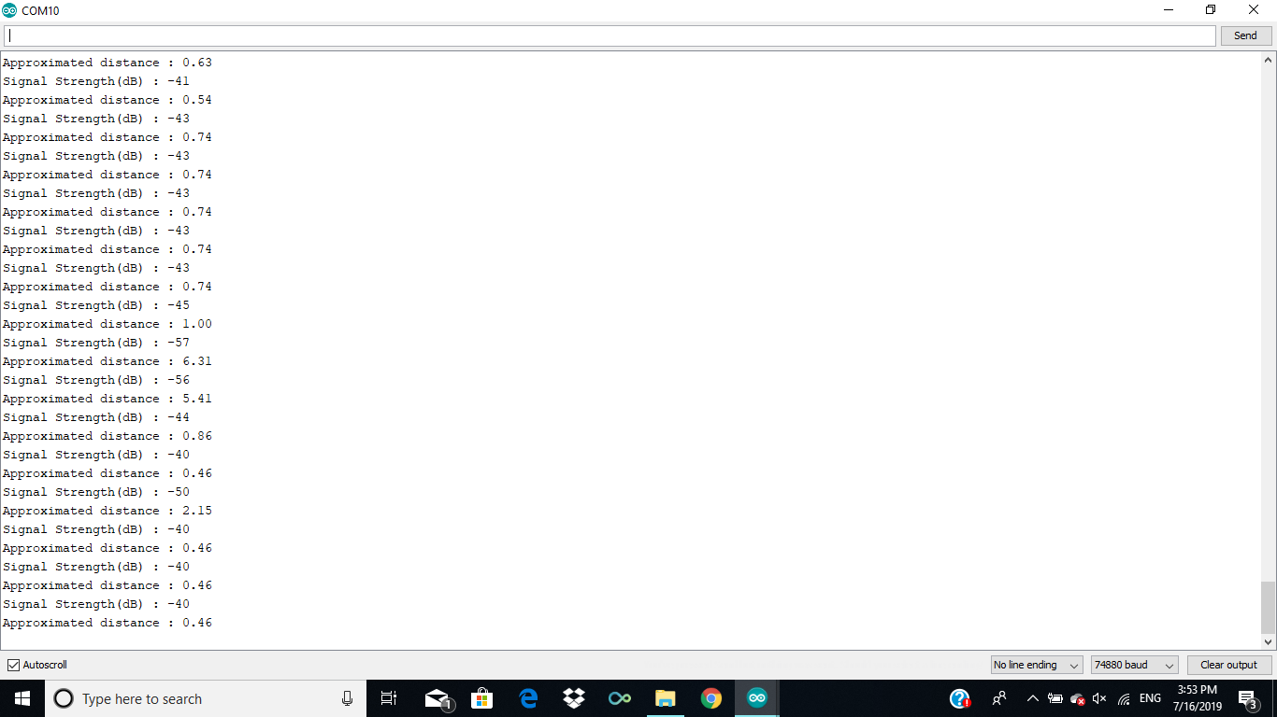

Plot of RSSI values of the WiFi signal

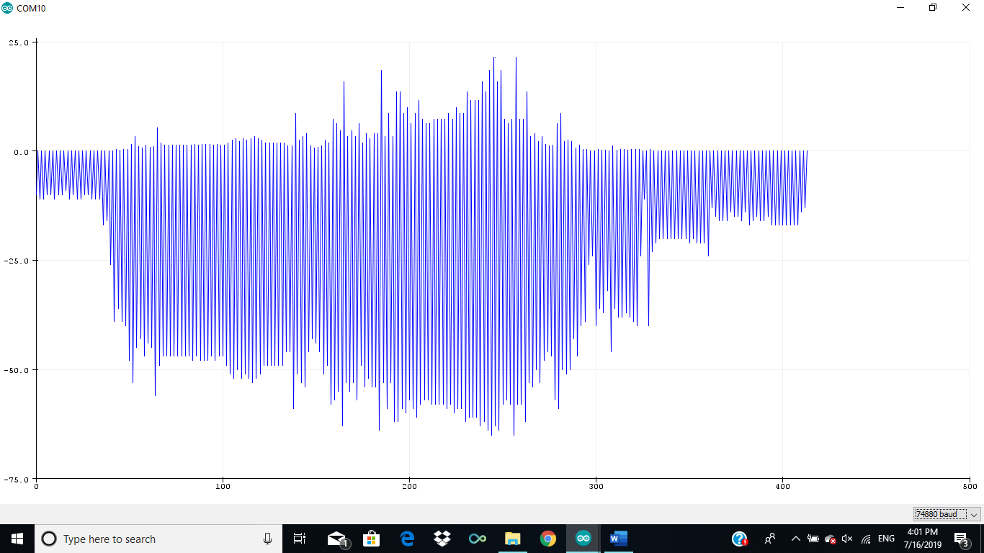

Signal strengths nearby/close to the ESP

